**Bamazon-Customer**

1. Database populated- info displayed ID, product name, price.

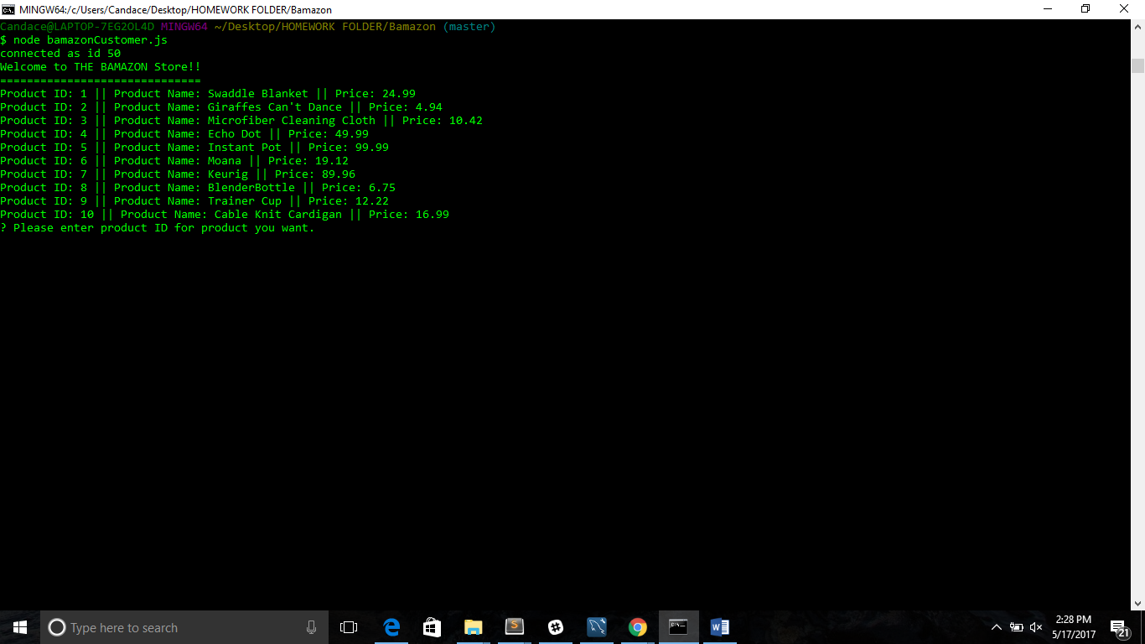

1. User prompted with two questions…

a. *ID of product they would like to buy*

b. *How many units of the product they would like to buy*

c. Also displaying insufficient stock for product chosen

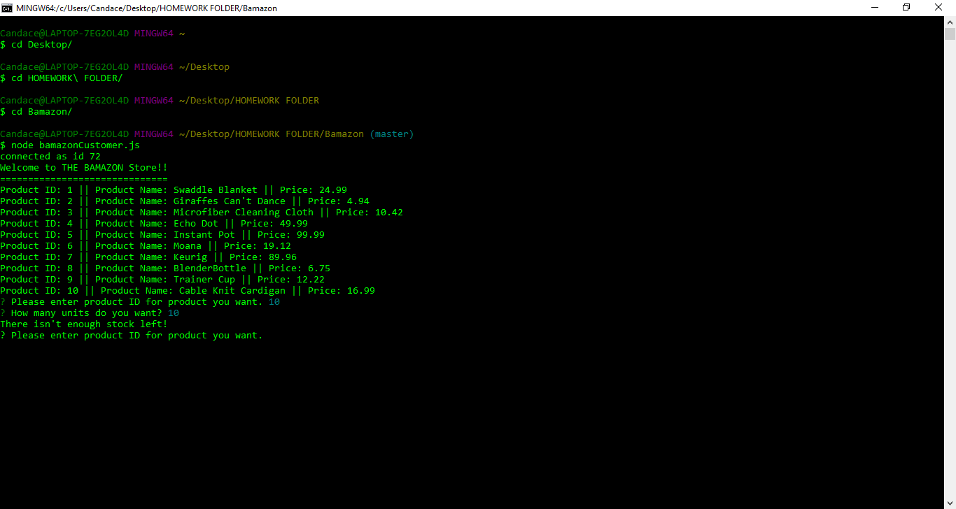

1. Customer’s order fulfilled, customer notified that purchase complete and total price for order.

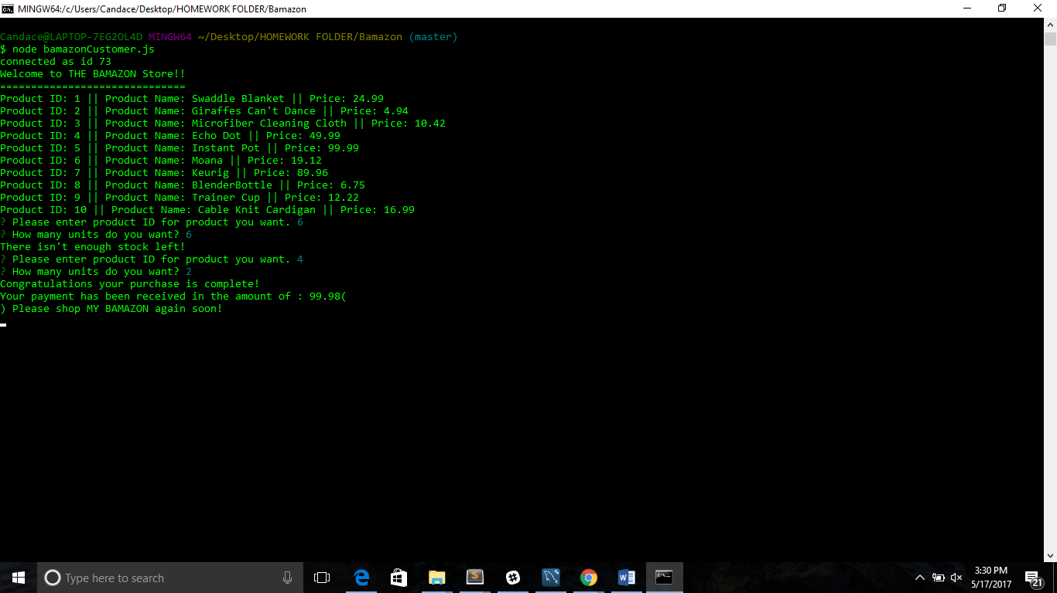

**Bamazon- Manager**

1. List of menu options displayed: *View Products for Sale, View Low Inventory, Add to Inventory, Add New Product*

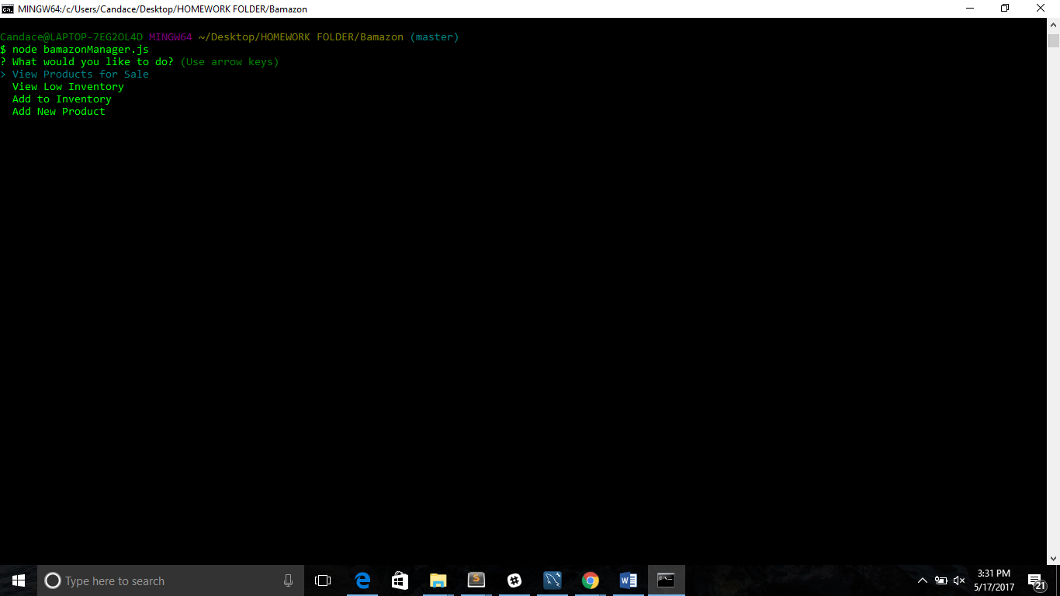

1. Manager selects: View Products for sale – Product ID, names, Prices and Quantities displayed.

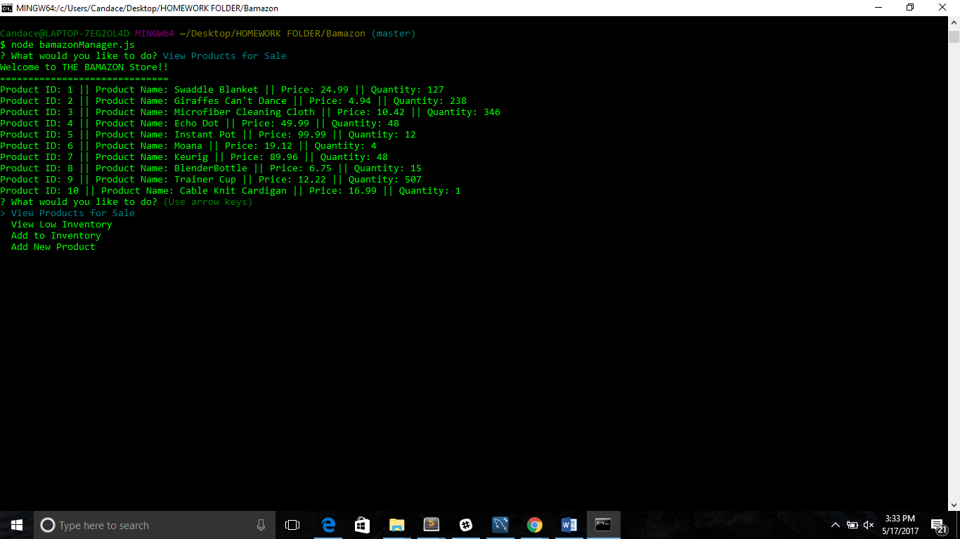

1. Manager selects: *View Low Inventory* -list of items with an inventory count lower than 5 displayed. --Product ID: 10 || Product Name: Cable Knit Cardigan || Quantity: 1 --Product ID: 6 || Product Name: Moana || Quantity: 4

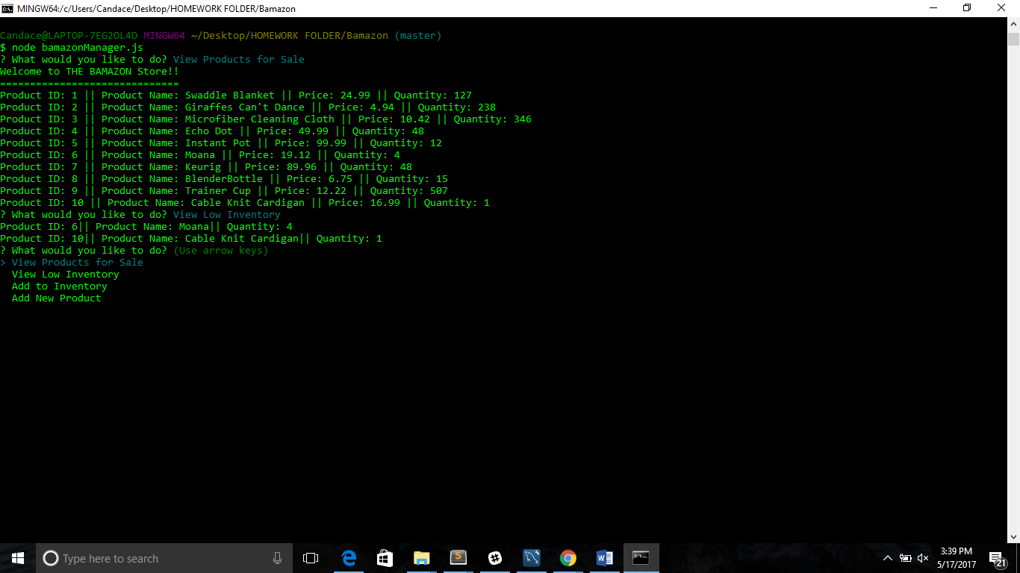

1. Manager Selects: *Add to Inventory*- prompted to let manager “add more” of any item currently in stock. --Product ID that manager would like to add stock to requested. --How much stock manager would like to add requested.

--Manager notified stock updated “Updated stock: 16” 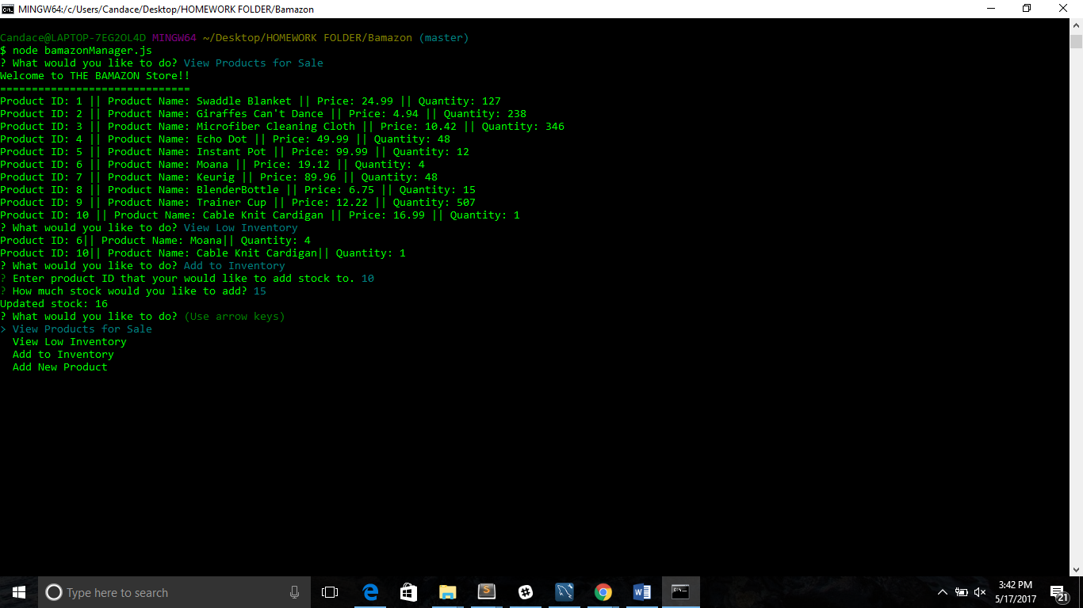

1. Display that product update was successful. “Cable Knit Cardigan || Quantity: 16”

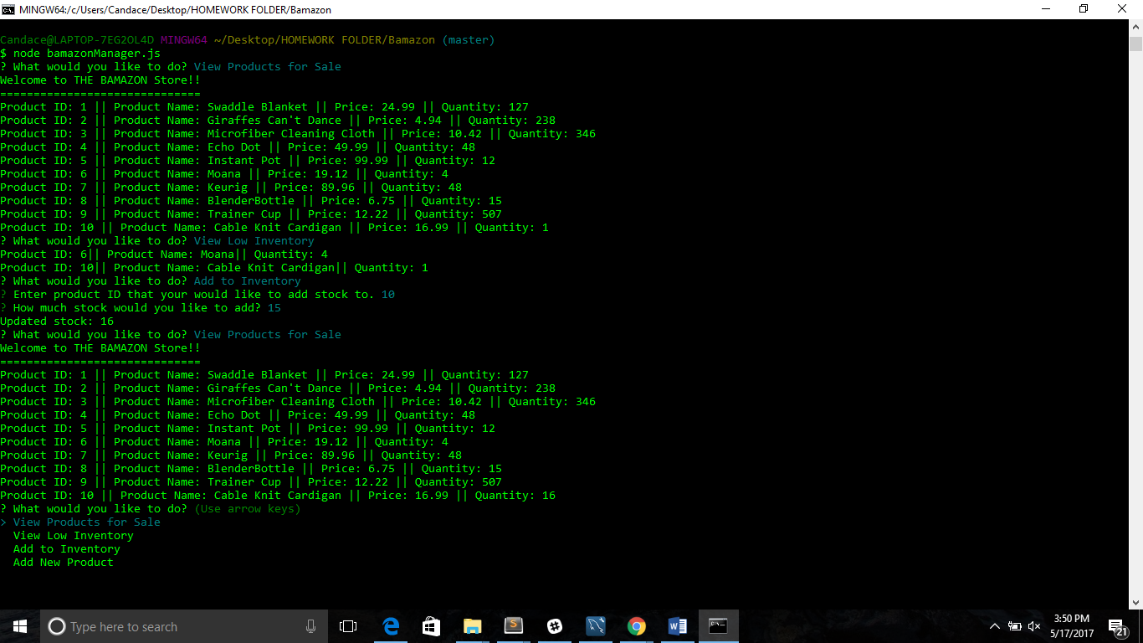

1. Manager Selects: *Add New Product* – manager allowed to add a completely new product to the store. --Manager is prompted about added product, department, and price. –Manager notified that product was added successfully and that the department “Clothing” is a exist.

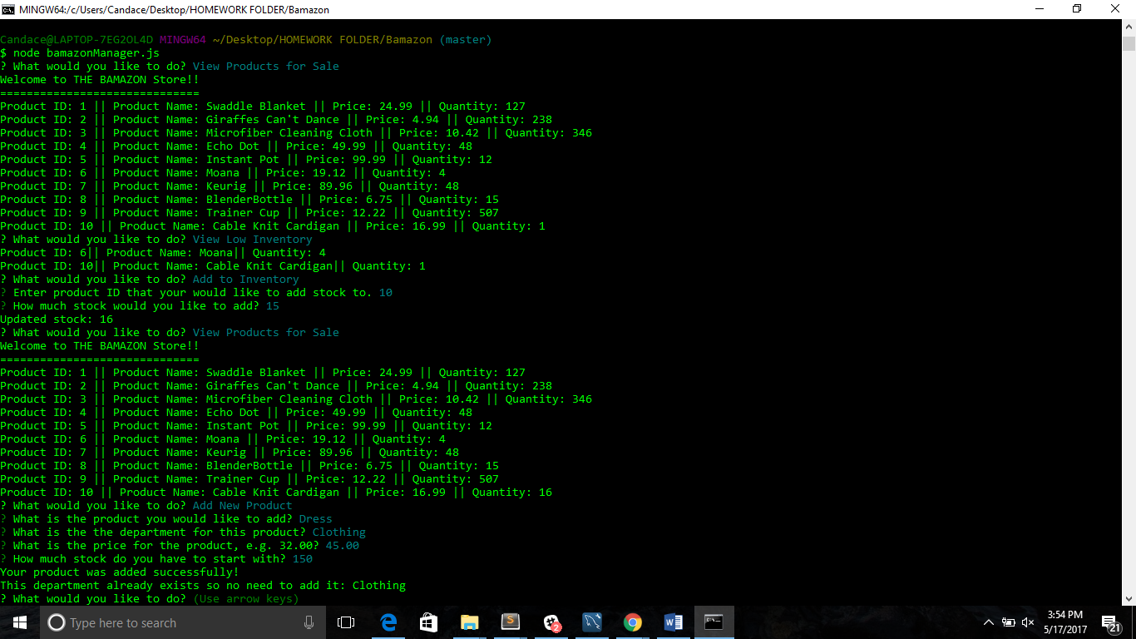

1. New product, price and quantity is displayed once manager re-selects View Product for sale.

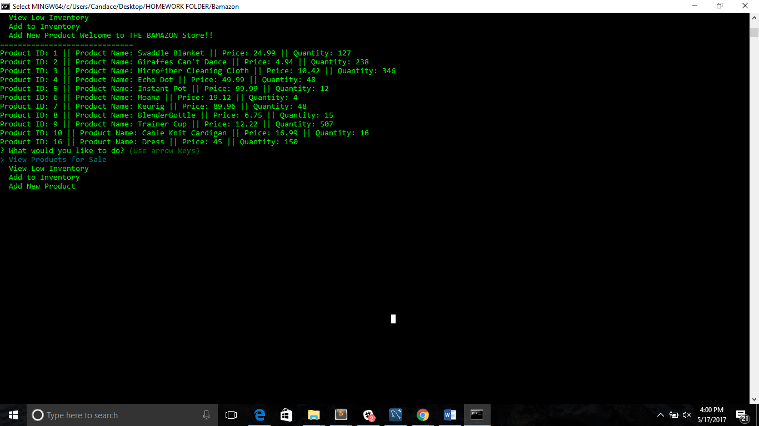

1. Manager Selects:

*Add New Product:* Selects product, department, price and quantity.

--Manager notified product and department added successfully.

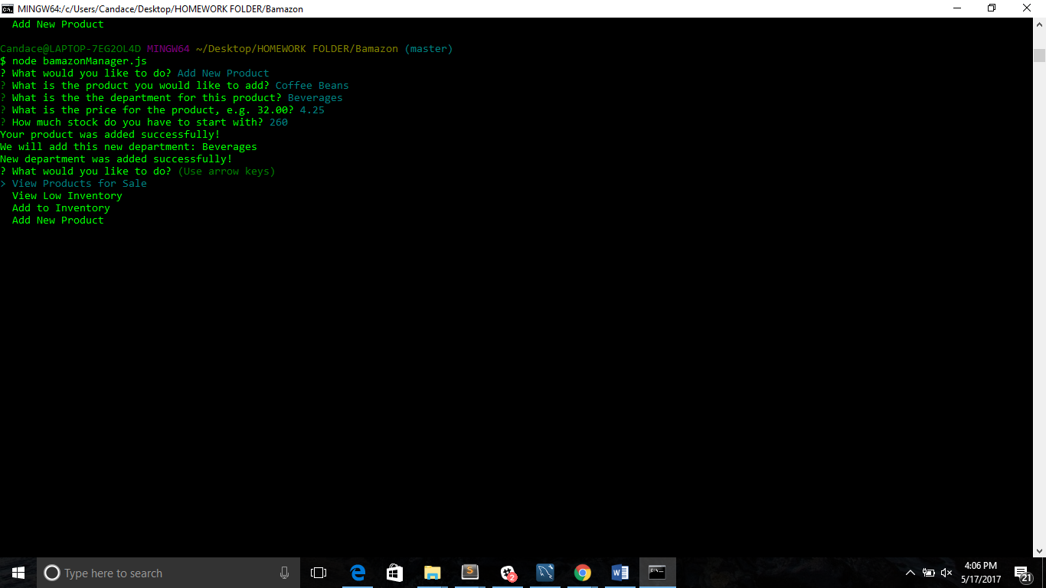

--New products and department displayed.

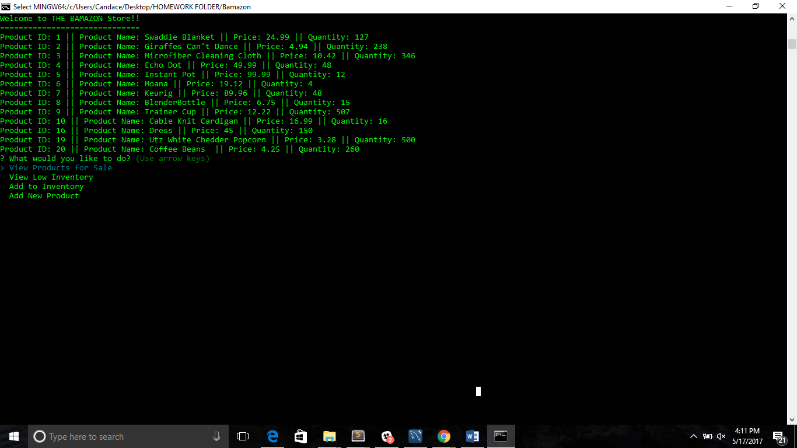

**Bamazon- supervisor**

1. Menu options provided to supervisor: *View Product Sales by Department* and *Create New Department.*

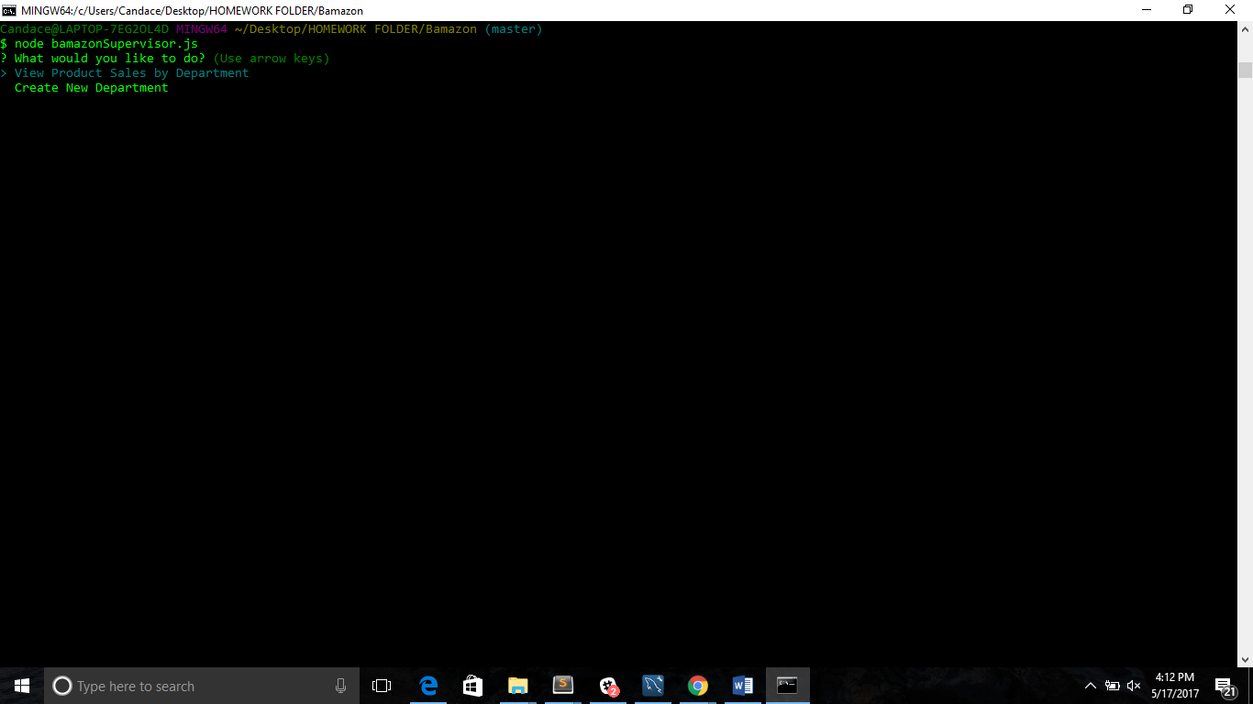

--Total profit and overhead displayed per department.

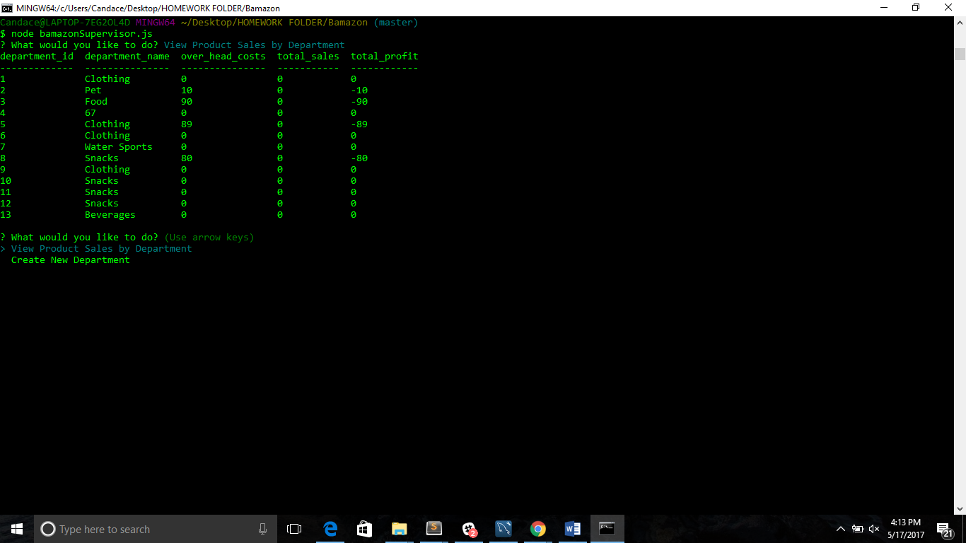

1. Supervisor prompted: --Create new department --Overhead cost for this department --Supervisor notified that department was added successfully. –New department “shoes” displayed.

